Install

Guide

(OpenMark Authoring Tool)

Description 3

Prerequisites 4

Environments 5

OpenMark Authoring Tool web application (GEPEQ) 7

OpenMark Authoring Tool database (gepeq) 9

‘OpenMark Developer’ web application (om-dev) 11

Preview Environment for OpenMark 13

‘OpenMark Test Navigator’ web application (om-tn) 13

‘OpenMark Question Engine’ web application (om-qe) 16

Starting up the preview environment for OpenMark 17

Integration testing of the preview environment with OpenMark Authoring Tool 19

Publication Environment for OpenMark 20

‘OpenMark Test Navigator’ web application (om-tn-pro) 20

‘OpenMark Question Engine’ web application (om-qe-pro) 23

Starting up the publication environment for OpenMark 24

Integration testing of the publication environment with Openmark Authoring Tool 26

Encryption 27

Generating public and private encryption keys 28

Encrypting properties 29

Properties supporting encryption 30

OpenMark Authoring Tool (GEPEQ) 30

‘OpenMark Test Navigator’ (om­tn, om­tn­pro) 30

Decrypting properties 31

Encryption for arguments of web services of ‘OpenMark Test Navigator’ web applications 32

# Description

The OpenMark Authoring Tool is a web application to generate questions and tests (consisting of questions) that can be executed with OpenMark.

OpenMark is on the other hand a system of tests capable of executing questions and tests.

On a technical level OpenMark doesn’t ease the task of creating questions to users without some programming knowledge, and for that reason we have developed the authoring tool.

The goals of the authoring tool are:

* Mainly that a user with basic computer skills will be able to easily create and modify questions and tests for OpenMark.
* That the application, be sure to inform the user of the fields that are not correctly filled and explain the reason for making it easy to fix.
* To make possible to run these questions and tests within a testing environment to verify that they are viewed and work as expected.
* To allow storage of multimedia resources that can be used with the questions.
* That all questions, tests and resources can be arranged in an orderly way to make it easier to locate.
* Make it possible for a user to have private access to some of his/her questions, tests and resources, so that only he/she (or someone with enough administration permissions) can access them, and at the same time that he/she has some way of making accessible other of his/her questions, tests and resources to other users.

# Prerequisites

Before the installation of different environments required by the OpenMark Authoring Tool we need to have the following software installed on the system:

* Java (JDK 6 or greater)
* Apache Tomcat web server (version 6 is recommended)
* Apache ANT 1.7.0 or greater
* PostgreSQL database server
* 'Verdana' and 'Times New Roman' fonts installed on the system, with all its variants.

# Environments

OpenMark authoring tool needs the following environments installed before working:

* ***OpenMark Authoring Tool* web application (*GEPEQ*)**: It is the main Java application used to generate questions and tests for OpenMark. Must be installed on Apache Tomcat server.
* ***OpenMark Authoring Tool* database (*gepeq*)**: It is the database used by OpenMark Authoring Tool. Currently only supported with PostgreSQL.
* ***‘OpenMark Developer’ web application* (*om-dev*)**: This web application is part of OpenMark and is used to compile questions and to generate the jar files required for its execution. It also allows you to run questions, but this functionality is not properly supported for multiuser environments, so this functionality for previewing OpenMark questions is not used. It is used a special implementation of OpenMark servlet (*om.devservlet.uned.DevServlet*) that has some special operations and web services invoked from Openmark Authoring Tool. Must be installed on Apache Tomcat server.
* **Preview environment for OpenMark**: It is needed a preview environment where you can preview questions and tests created with the OpenMark authoring tool before publishing them.

This environment consists of three sub-environments:

1. *‘OpenMark Test Navigator’ web application (om-tn)*: This web application is part of OpenMark and is used to display questions and tests. It is used a special implementation of OpenMark servlet (*om.tnavigator.uned.PreviewNavigatorServlet*) that has some special operations ans web services invoked from OpenMark Authoring Tool. Must be installed on Apache Tomcat server.
2. *‘OpenMark Test Navigator’ database*: It is the database used by *'OpenMark Test Navigator'* to save the users progress and results. For now we have PostgreSQL and SQL Server support for this database, but we recommend using PostgreSQL.
3. *‘OpenMark Question Engine’ web application (om-qe)*: This web application is part of OpenMark and it is used through web services. They also have been defined special web services invoked from OpenMark authoring tool. Must be installed on Apache Tomcat server.

* **Publication environment for OpenMark**: It is needed a publication environment where you can publish questions and tests created with OpenMark authoring tool, so that they are accessible by all other users.

This environment consists of three sub-environments:

1. *‘OpenMark Test Navigator’ web application (om-tn-pro)*: This web application is part of OpenMark and is used to display questions and tests. It is used a special implementation of OpenMark servlet (*om.tnavigator.uned.LogoutNavigatorServlet*) that has some special operations ans web services invoked from OpenMark Authoring Tool. Must be installed on Apache Tomcat server.
2. *‘OpenMark Test Navigator’ database*: It is the database used by *'OpenMark Test Navigator'* to save the users progress and results. For now we have PostgreSQL and SQL Server support for this database, but we recommend using PostgreSQL.
3. *‘OpenMark Question Engine’ web application (om-qe-pro)*: This web application is part of OpenMark and it is used through web services. Must be installed on Apache Tomcat server.

# OpenMark Authoring Tool web application (GEPEQ)

To install OpenMark Authoring Tool web application must follow the following steps:

1. Create a folder *'gepeq'* within the folder *'webapps'* of the Apache Tomcat server.
2. Copy the entire contents of the folder *'WebContent'* within the folder *'gepeq'* we just created.
3. Create a folder *‘classes’* within the folder *‘webapps/gepeq/WEB­INF’* of the Apache Tomcat server.
4. Copy the entire contents of the folder *‘build/classes’* within the folder *‘webapps/gepeq/WEB-INF’* of the Apache Tomcat server we just created.
5. Edit *'configuration.xml'* file located within folder *‘webapps/gepeq/WEB­INF’* of Apache Tomcat server:
   * In case we access Internet via proxy we must set appropriate values in the following properties:

*<Proxy­URL>*, *<Proxy­Port>*, *<Proxy­Username>,* *<Proxy­Password>* y *<Non­Proxy­Hosts>*.

* + If we don’t access Internet via proxy we must remove or comment previous settings.
  + The remaining settings can be left as they are, at least until you have installed all other environments.

1. Restart Apache Tomcat server.

You can check that this environment has been installed correctly by accessing the website of the application, which in case you are using a local machine by default will be <http://localhost:8080/gepeq/>

If you have done everything right, you will see the home page of the OpenMark authoring tool:

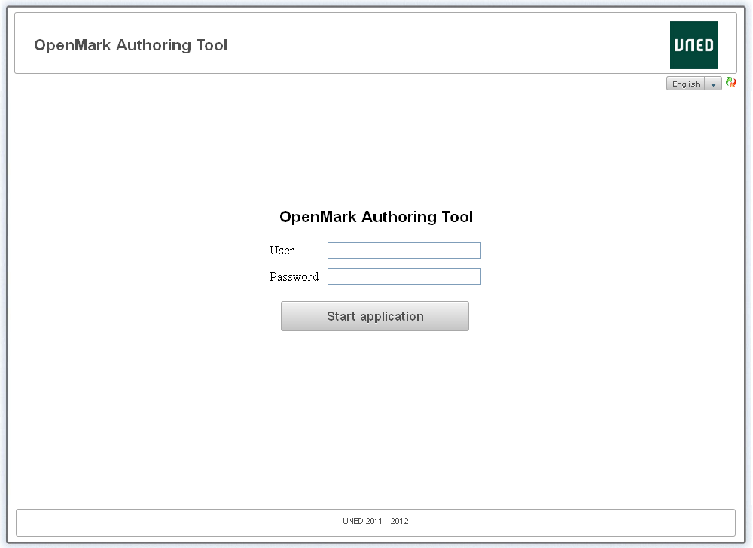

Although already displays the home page of the OpenMark authoring tool, if you press the *'Start application'* button an error will occur because the database used by the OpenMark authoring tool has not been installed.

# OpenMark Authoring Tool database (gepeq)

To install the database used by the OpenMark authoring tool you must run the last script 'gepeq­uned­*yyyymmdd*.sql' you have at the folder *'dbscripts'* with PostgreSQL.

Moreover it is possible that you have to apply some of the patches at folder *'dbscripts/patches'*.

Specifically you must run all those patches 'patch­gepeq­*yyyymmdd*­.... sql' with a later date than the date of the file used to create the database, and do it in chronological order from oldest to newer patch.

You also need to edit the *'hibernate.cfg.xml'* file located within folder *'webapps/gepeq/WEB­INF/classes'* with the data connection to the database you have created:

* + *<property name=”connection.provider.class”>*. This property can be deleted or commented out if we are not going to encrypt the information on the data connection.
  + *<property name="hibernate.dialect">*. As you are using a PostgreSQL database you must set the value: *org.hibernate.dialect.PostgreSQLDialect*
  + *<property name="hibernate.connection.driver_class">*. As you are using a PostgreSQL database you must set the value: *org.postgresql.Driver*
  + *<property name="hibernate.connection.url">*. Here you must provide the connection string to the database, in case you are using a local machine by default will be *jdbc:postgresql://localhost:5432/gepeq*
  + *<property name="hibernate.connection.username">*. Here you must provide the username of a PostgreSQL user with read and write permissions on the database.
  + *<property name="hibernate.connection.password">* Here you must provide password of the PostgreSQL user above.

If you have successfully installed the database, and once you have restarted the Apache Tomcat server, you should now be able to log in from the home page authoring tool for OpenMark as:

**User**: profesor

**Password**: profesor

Doing so displays the page *'Questions'* of the OpenMark authoring tool (there should be no questions):

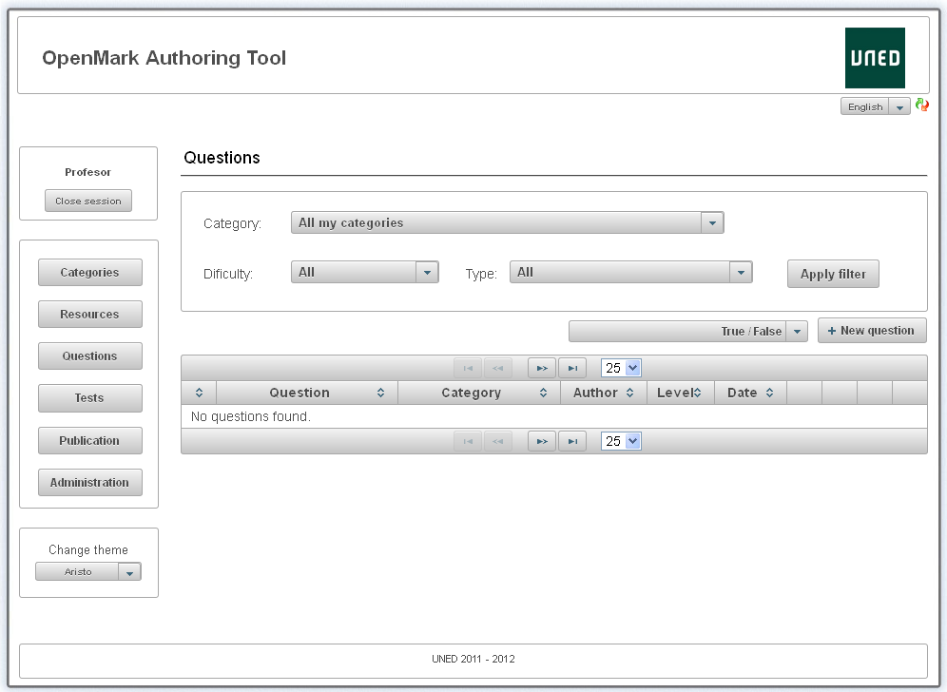

Now it should work almost the entire application, only will fail when you try to preview OpenMark questions/tests or accessing the page 'Publication'.

To fix it you need to install all the other environments.

# ‘OpenMark Developer’ web application (om-dev)

To install *‘OpenMark Developer’* web application (*om-dev*) must follow the following steps:

1. Create a folder *'om'* within the folder *'webapps'* of the Apache Tomcat server.
2. Copy the entire contents of the folder *'om/WebContent'* within the folder *'om'* you just created.
3. Edit *'web.xml'* file located within folder *‘webapps/om/WEB­INF’* of Apache Tomcat server:
   * You must put the correct path to our Java Runtime Environment (JRE 6+) within the tag *<param­value></param­value>* corresponding to *<param­name>****jdk­home****</param­name>*.
   * You must put the correct path to our installed version of Apache ANT within the tag *<param­value></param­value>* corresponding to *<param­name>****ant-home****</param­name>*.
   * You must check that within the tag *<servlet­class></servlet­class>* we have the value: *om.devservlet.uned.DevServlet* to properly support some features and web services required by the OpenMark authoring tool.
4. Edit *‘configuration.xml’* file located within folder *‘webapps/gepeq/WEB­INF’* of Apache Tomcat server:
   * You must put the correct address to the website of the *‘OpenMark Developer’* web application (*om­dev*) within the *<OmUrl>* property, in case you are using a local machine by default will be <http://localhost:8080/om/>
5. Restart Apache Tomcat server.

You can check that this environment has been installed correctly by accessing the website of the application, which in case you are using a local machine by default will be <http://localhost:8080/om/>

If you have done everything right, you will see next page:

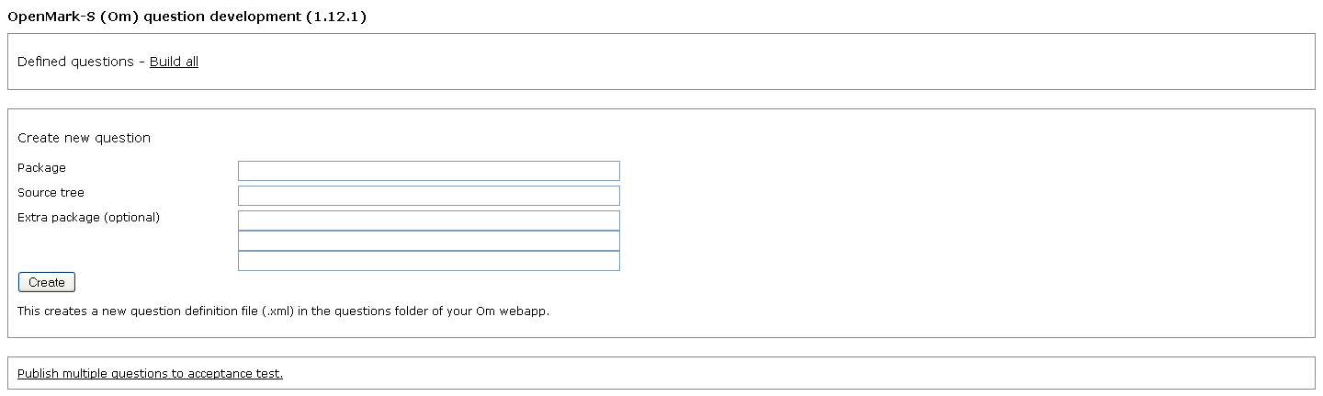

It is possible using this environment to compile OpenMark questions manually, but the OpenMark authoring tool is able to invoke this environment transparently to the user, so unless you want to compile complex questions, you won't need to use this application.

Moreover, when you create or compile questions from this environment, the changes are not reflected within the OpenMark authoring tool, so it is not recommended doing it from here.

# Preview Environment for OpenMark

To preview questions and/or tests from the OpenMark authoring tool, in addition to the *'OpenMark Developer'* web application (*om*), you need to install a preview environment that consists of 2 web applications: *‘OpenMark Test Navigator’* (*om­tn*) and ‘*OpenMark Question Engine’* (*om­qe*) and a database used by the ‘*OpenMark Test Navigator’* web application (*om­tn*) that will be generated automatically when you start the application for the first time (provided you have configured everything correctly).

## ‘OpenMark Test Navigator’ web application (om-tn)

To install *‘OpenMark Test Navigator’* web application (*om-tn*) must follow the following steps:

1. Create a folder *'om­tn'* within the folder *'webapps'* of the Apache Tomcat server.
2. Copy the entire contents of the folder *'om­tn/WebContent'* within the folder *'om­tn'* you just created.
3. Create an empty database for use with the *"OpenMark Test Navigator"* web application (*om-tn*) on the database server you want. There is only support for PostgreSQL and SQL Server databases, but it is recommended to use PostgreSQL.
4. Edit *'web.xml'* file located within folder *‘webapps/om­tn/WEB­INF’* of Apache Tomcat server:
   * You must check that within the tag *<servlet­class></servlet­class>* you have the value: *om.tnavigator.uned.PreviewNavigatorServlet* to properly support some features and web services required by the OpenMark authoring tool.
5. Edit *'navigator.xml'* file located within folder *‘webapps/om­tn’* of Apache Tomcat server:
   * You must configure the connection data to the database of the *‘OpenMark Test Navigator’* web application (*om­tn*) within the tags *<database plugin="..."> </ database>*. The attribute *‘plugin’* must specify the full name of the Java class used to execute SQL statements that access the database. If you use a PostgreSQL database must be *om.tnavigator.db.postgres.uned.PostgreSQL*, whereas if you use SQL Server must be *om.tnavigator.db.sqlserver.SQLServer*

Within the *<server></server>* tag you must indicate the name of the server where the database is located, which in the case of a local machine by default will be *localhost*

Within the *<name></name>* tag you must indicate the name of the empty database you created earlier.

Within the *<prefix></prefix>* tag you can indicate an optional prefix that will be added at the beginning of the name of all tables.

Within *<username></username>* tag you must indicate the username of a database user with full access to the database, including the ability to create tables.

Finally, within *<password></password>* tag you must specify the password for the above user.

* + You must configure the connection data to the database of the *‘Openmark authoring tool’* web application (*gepeq*) within the tags *<login­db></login­db>* found within the *<security>* tag.

Within the *<server></server>* tag you must indicate the name of the server where the database is located, which in the case of a local machine by default will be *localhost*

Within the *<name></name>* tag you must indicate the name of the empty database you created earlier.

Within *<username></username>* tag you must indicate the username of a database user with full access to the database, including the ability to create tables.

Finally, within *<password></password>* tag you must specify the password for the above user.

* + You must put the correct address to the website of the *'OpenMark Test Navigator'* web application (*om­tn*) within the tags *<testnavigators><url this=”yes”></url></testnavigators>*, in case you are using a local machine by default will be <http://localhost:8080/om-tn/>
  + You can set email addresses alerts inside the tags *<alertmails> </alertmails>*, so that an alert is sent to them when any error occurs, *<from>* label is used to indicate the email address used as the sender of the alert (also used in the support contact and evaluation messages), and labels *<cc>*, *<to>* can be used as recipients for these alerts.
  + You can specify a password to decrypt some arguments sent via web services from the OpenMark authoring tool within *<gepeq­decryption­password>* tag found within *<security>* tag (see Encryption for arguments of web services of ‘OpenMark Test Navigator’ web applications).

If you do not want to use encryption on passing arguments to the Web services, comment out or remove this property.

* + You can configure the SMTP server used by the web application to send mails with different properties that are within the *<mail>* tag. There are presets for the most common SMTP servers (Gmail, Yahoo! Mail and Hotmail) that can be indicated within the *<config>* property. You can use *<username>* and *<password>* properties to indicate the username and password used to connect to the SMTP server. Finally, if you want to configure a different SMTP server, you can use the properties *<hostname>*, *<port>*, *<ssl>*, *<start­tls>* and *<debug>*.

1. Edit *‘configuration.xml’* file located within folder *‘webapps/gepeq/WEB­INF’* of Apache Tomcat server:
   * You must put the correct address to the website of the *‘OpenMark Test Navigator’* web application (*om­tn*) within the *<OmTnUrl>* property, in case you are using a local machine by default will be <http://localhost:8080/om­tn/>
   * If you set a password on the property *<gepeq­decryption­password>* within the *'navigator.xml'* file of the *'OpenMark Test Navigator'* web application (*om­tn*), you must set the property *<OmTnEncryptionPassword>* with the same password (see Encryption for arguments of web services of ‘OpenMark Test Navigator’ web applications).

Otherwise you must comment out or remove that property.

## ‘OpenMark Question Engine’ web application (om-qe)

To install *‘OpenMark Question Engine’* web application (*om-qe*) must follow the following steps:

1. Create a folder *‘om­qe’* within the folder ‘*webapps’* of the Apache Tomcat server.
2. Copy the entire contents of the folder *‘om­qe/WebContent’* within the folder *‘om­qe’* you just created.
3. Edit *‘navigator.xml’* file located within folder *‘webapps/om­tn’* of Apache Tomcat server:
   * You must put the correct address to the web services of the *'OpenMark Question Engine'* web application (*om­qe*) within the tags *<question engines type=“application/x­opaque”><url this=”yes”> </url></questionengines>*, in case you are using a local machine by default will be <http://localhost:8080/om-qe/services/Om>
4. Edit *‘configuration.xml’* file located within folder *‘webapps/gepeq/WEB­INF’* of Apache Tomcat server:
   * You must put the correct address to the *'OpenMark Question Engine'* web application (*om­tn*) within the *<OmQeUrl>* property, in case you are using a local machine by default will be <http://localhost:8080/om­qe/>

## Starting up the preview environment for OpenMark

If you followed the above steps correctly, the tables for the database used by the *‘OpenMark Test Navigator’* web application (*om­tn*) should not have been created yet, but you will be ready to start it up so that the database will be automatically generated.

The *‘OpenMark Test Navigator’* web application (*om­tn*) doesn't have a home page, so to make it easier to try it there are some preinstalled tests.

To force the database used by *‘OpenMark Test Navigator’* (*om­tn*) to be generated and to check that everything works correctly it is recommended to restart the Apache Tomcat server and to access the address of *‘uned.module5’* preinstalled test, which in the case you are using a local machine by default will be <http://localhost:8080/om­tn/uned.module5/>

In case you have followed all the steps correctly you should see the following page:

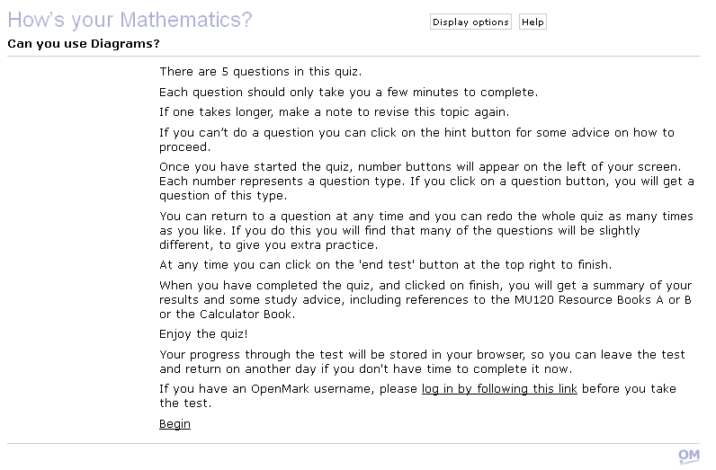

You can also verify that this is the preview environment by clicking the link *‘log in by following this link’*:

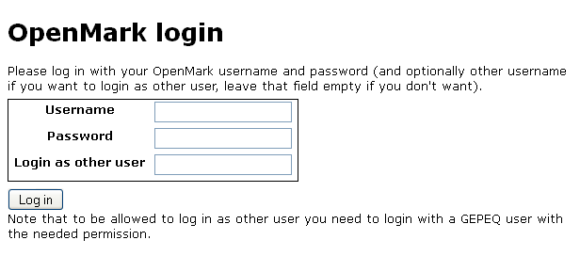

Since this is a preview environment, you should see the field *‘Login as other user’*, which allows users to impersonate other user without knowing his/her password (for logging testing).

If you don't see this field you probably have not configured correctly the value of the *<servlet-class></servlet-class>* tag within the *‘web.xml’* file located in the folder *‘webapps/om­tn/WEB­INF’* of the Apache Tomcat server.

## Integration testing of the preview environment with OpenMark Authoring Tool

If you followed all steps correctly, the *'OpenMark Authoring Tool'* web application (*GEPEQ*) and the preview environment should have been installed correctly.

To check that the communication between the *'OpenMark Authoring Tool'* web application (*GEPEQ*) and the preview environment is working properly, it is recommended to create a question and a test with the authoring tool and try to preview them.

If they are previewed correctly is that the environments have been properly installed.

Otherwise you should review the configuration files of these applications, because probably something is not correctly configured.

# Publication Environment for OpenMark

To publish questions and/or tests from the OpenMark authoring tool, in addition to the *'OpenMark Developer'* web application (*om*), you need to install a publication environment that consists of 2 web applications: *‘OpenMark Test Navigator’* (*om­tn­pro*) and *"OpenMark Question Engine"* (*om­qe­pro*) and a database used by the ‘*OpenMark Test Navigator’* web application (*om­tn­pro*) that will be generated automatically when you start the application for the first time (provided you have configured everything correctly).

## ‘OpenMark Test Navigator’ web application (om-tn-pro)

To install *‘OpenMark Test Navigator’* web application (*om-tn*) must follow the following steps:

1. Create a folder *'om­tn­pro'* within the folder *'webapps'* of the Apache Tomcat server.
2. Copy the entire contents of the folder *'om­tn­pro/WebContent'* within the folder *'om­tn­pro'* you just created.
3. Create an empty database for use with the *"OpenMark Test Navigator"* web application (*om-tn-pro*) on the database server you want. There is only support for PostgreSQL and SQL Server databases, but it is recommended to use PostgreSQL.
4. Edit *'web.xml'* file located within folder *‘webapps/om­tn­pro/WEB­INF’* of Apache Tomcat server:
   * You must check that within the tag *<servlet­class></servlet­class>* you have the value: *om.tnavigator.uned.LogoutNavigatorServlet* to properly support some features and web services required by the OpenMark authoring tool.
5. Edit *'navigator.xml'* file located within folder *‘webapps/om­tn­pro’* of Apache Tomcat server:
   * You must configure the connection data to the database of the ‘*OpenMark Test Navigator’* web application (*om­tn­pro*) within the tags *<database plugin="..."> </ database>*. The attribute *‘plugin’* must specify the full name of the Java class used to execute SQL statements that access the database. If you use a PostgreSQL database must be *om.tnavigator.db.postgres.uned.PostgreSQL*, whereas if you use SQL Server must be *om.tnavigator.db.sqlserver.SQLServer*

Within the *<server></server>* tag you must indicate the name of the server where the database is located, which in the case of a local machine by default will be *localhost*

Within the *<name></name>* tag you must indicate the name of the empty database you created earlier.

Within the *<prefix></prefix>* tag you can indicate an optional prefix that will be added at the beginning of the name of all tables.

Within *<username></username>* tag you must indicate the username of a database user with full access to the database, including the ability to create tables.

Finally, within *<password></password>* tag you must specify the password for the above user.

* + You must configure the connection data to the database of the *‘Openmark authoring tool’* web application (*gepeq*) within the tags *<login­db></login­db>* found within the *<security>* tag.

Within the *<server></server>* tag you must indicate the name of the server where the database is located, which in the case of a local machine by default will be *localhost*

Within the *<name></name>* tag you must indicate the name of the empty database you created earlier.

Within *<username></username>* tag you must indicate the username of a database user with full access to the database, including the ability to create tables.

Finally, within *<password></password>* tag you must specify the password for the above user.

* + You must put the correct address to the website of the *'OpenMark Test Navigator'* web application (*om­tn­pro*) within the tags *<testnavigators><url this=”yes”></url></testnavigators>*, in case you are using a local machine by default will be <http://localhost:8080/om-tn­pro/>
  + You can set email addresses alerts inside the tags *<alertmails> </alertmails>*, so that an alert is sent to them when any error occurs, *<from>* label is used to indicate the email address used as the sender of the alert (also used in the support contact and evaluation messages), and labels *<cc>*, *<to>* can be used as recipients for these alerts.
  + You can specify a password to decrypt some arguments sent via web services from the OpenMark authoring tool within *<gepeq­decryption­password>* tag found within *<security>* tag (see Encryption for arguments of web services of ‘OpenMark Test Navigator’ web applications).

If you do not want to use encryption on passing arguments to the Web services, comment out or remove this property.

* + You can configure the SMTP server used by the web application to send mails with different properties that are within the *<mail>* tag. There are presets for the most common SMTP servers (Gmail, Yahoo! Mail and Hotmail) that can be indicated within the *<config>* property. You can use *<username>* and *<password>* properties to indicate the username and password used to connect to the SMTP server. Finally, if you want to configure a different SMTP server, you can use the properties *<hostname>*, *<port>*, *<ssl>*, *<start­tls>* and *<debug>*.

1. Edit *‘configuration.xml’* file located within folder *‘webapps/gepeq/WEB­INF’* of Apache Tomcat server:
   * You must put the correct address to the website of the *‘OpenMark Test Navigator’* web application (*om­tn­pro*) within the *<OmTnProUrl>* property, in case you are using a local machine by default will be <http://localhost:8080/om-tn­pro/>
   * If you set a password on the property *<gepeq­decryption­password>* within the *'navigator.xml'* file of the *'OpenMark Test Navigator'* web application (*om­tn­pro*), you must set the property *<OmTnProEncryptionPassword>* with the same password (see Encryption for arguments of web services of ‘OpenMark Test Navigator’ web applications).

Otherwise you must comment out or remove that property.

## ‘OpenMark Question Engine’ web application (om-qe-pro)

To install *‘OpenMark Question Engine’* web application (*om-qe-pro*) must follow the following steps:

1. Create a folder *‘om­qe­pro’* within the folder *‘webapps’* of the Apache Tomcat server.
2. Copy the entire contents of the folder *‘om­qe­pro/WebContent’* within the folder *‘om­qe’* you just created.Copiar todo el contenido de la carpeta *‘om­qe/WebContent’* dentro de la carpeta *‘om­qe­pro’* que acabamos de crear.
3. Edit *‘navigator.xml’* file located within folder *‘webapps/om­tn­pro’* of Apache Tomcat server:
   * You must put the correct address to the web services of the *'OpenMark Question Engine'* web application (*om­qe­pro*) within the tags *<question engines type=“application/x­opaque”><url this=”yes”> </url></questionengines>*, in case you are using a local machine by default will be <http://localhost:8080/om-qe-pro/services/Om>

## Starting up the publication environment for OpenMark

If you followed the above steps correctly, the tables for the database used by the *‘OpenMark Test Navigator’* web application (*om­tn­pro*) should not have been created yet, but you will be ready to start it up so that the database will be automatically generated.

The *‘OpenMark Test Navigator’* web application (*om­tn­pro*) doesn't have a home page, so to make it easier to try it there are some preinstalled tests.

To force the database used by *‘OpenMark Test Navigator’* (*om­tn­pro*) to be generated and to check that everything works correctly it is recommended to restart the Apache Tomcat server and to access the address of *‘uned.module5’* preinstalled test, which in the case you are using a local machine by default will be <http://localhost:8080/om­tn-pro/uned.module5/>

In case you have followed all the steps correctly you should see the following page:



You can also verify that this is the publication environment by clicking the link *‘log in by following this link’*:

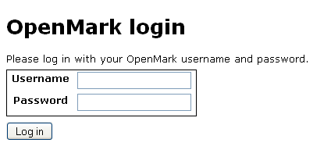

Since this is a publication environment, you should only see *‘Username’* and *‘Password’* fields.

If you see some other field you probably have not configured correctly the value of the *<servlet-class></servlet-class>* tag within the *‘web.xml’* file located in the folder *‘webapps/om­tn­pro/WEB­INF’* of the Apache Tomcat server.

## Integration testing of the publication environment with Openmark Authoring Tool

If you followed all steps correctly, the *'OpenMark Authoring Tool'* web application (*GEPEQ*) and the preview and publication environments should have been installed correctly.

To check that the communication between the *'OpenMark Authoring Tool'* web application (*GEPEQ*) and the publication environment is working properly, it is recommended to publish a question and a test with the authoring tool and try to run them.

If they are published and executed correctly is that the environments have been properly installed (once they are verified you can delete them).

Otherwise you should review the configuration files of these applications, because probably something is not correctly configured.

# Encryption

It is possible to encrypt some of the configuration data of the different environments for security.

To encrypt/decrypt these values it has been chosen an asymmetric encryption system with a pair of encryption keys: a public key for encrypting and a private key for decrypting.

## Generating public and private encryption keys

To configure the different environments for using encryption, you need to generate a pair of public and private encryption keys.

Currently it is possible to configure this encryption system for the *‘OpenMark Authoring Tool’* web application (*GEPEQ*) and for the *‘OpenMark Test Navigator’* web application, both preview (*om*­*tn*) and publication (*om­tn­pro*) environments, being possible to use the same key pair for all of them or to use different key pairs if you want to increase security.

In any case, to generate the key pairs you can use an encryption tool located at the folder *‘encryption’*:

*java -jar assymmetric-encryptor.jar savekeypair_enc_priv:.*

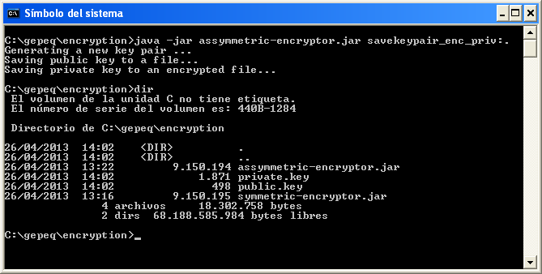

This generates a *‘public.key’* file with the public key and a *‘private.key’* file with the private key.

The *‘public.key’* file can be distributed to anyone who you want to allow encrypting messages.

The *‘private.key’* file must be distributed only to those people who actually you want to decrypt the information from configuration files.

We also need to put *‘private.key’* files within the *‘WEB­INF/security’* folder of the corresponding web applications: *‘OpenMark authoring tool’* (*GEPEQ*) and *‘OpenMark Test Navigator’*, both the preview environment (*om­tn*) and the publication environment (*om­tn­pro*).

Obviously these web applications need permission to read from those *‘private.key’* files.

## Encrypting properties

To generate an encrypted message from a string (with the password or data to encrypt), you can use the same program used to generate the encryption key pair.

For encrypting you only need permission to read from the *‘public.key’* file that contains the public encryption key:

*java - jar assymmetric-encryptor.jar encrypt:. password -o output.txt*

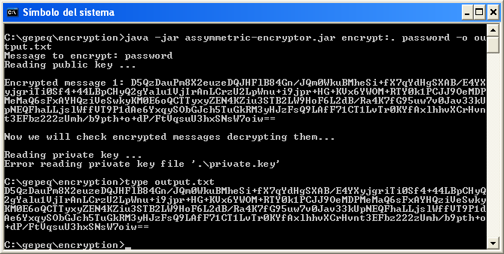

This command generates the *'output.txt'* file with the encrypted message from the string: *password*

The error message displayed is not important, it is because you can not access the *‘private.key’* file to decrypt the recent encrypted message (or because that file does not have the expected format), but this only serves as a check, not really required.

In case you need to encrypt a string with whitespaces, you must be careful to put quotes.

Alternatively you can specify a text file with the message to encrypt (whitespaces will be taken into account but line breaks will be ignored):

*java -jar assymmetric-encryptor.jar encrypt:. -i input.txt -o output.txt*

## Properties supporting encryption

Encryption is not supported for all properties from configuration files.

### OpenMark Authoring Tool (GEPEQ)

In the *‘web.xml’* file located within the folder *‘webapps/om­tn­pro/WEB­INF’* of the Apache Tomcat server, you can only encrypt the *<Proxy­Password>* property.

The *‘hibernate.cfg.xml’* file located within the folder *‘webapps/gepeq/WEB­INF/classes’* of the Apache Tomcat server does not support encryption by default, but you can enable it by assigning the value *es.uned.lsi.gepec.util.hibernate.EncryptedDriverManagerConnectionProvider* to the property *<property name="connection.provider_class">*

Even if you have enabled encryption for *‘hibernate.cfg.xml’* file, only the following properties will support encryption:

* + *<property name="hibernate.dialect">*
  + *<property name="hibernate.connection.driver_class">*
  + *<property name="hibernate.connection.url">*
  + *<property name="hibernate.connection.username">*
  + *<property name="hibernate.connection.password">*

### ‘OpenMark Test Navigator’ (om­tn, om­tn­pro)

In the case of *‘OpenMark Test Navigator’* web application, for both preview environment (*om­tn*) and publication environment (*om­tn­pro*), you can encrypt several properties of the *‘navigator.xml’* file:

* + Within *<database>* tag:
    - *<server>*
    - *<name>*
    - *<username>*
    - *<password>*
  + Within *<login-db>* tag (which is itself located within *<security>* tag):
    - *<server>*
    - *<name>*
    - *<username>*
    - *<password>*
  + Within *<mail>* tag:
    - *<username>*
    - *<password>*

## Decrypting properties

Although the authoring tool for OpenMark can decrypt itself encrypted properties of the configuration files (if it is configured correctly), sometimes you may need to retrieve passwords or encrypted data.

To do this you must have access to the 'private.key' file that contains the private key encryption.

The command for decrypting, using the same program used above, is:

*java -jar assymmetric-encryptor.jar decrypt_enc_priv:. -i input.txt -o output.txt*

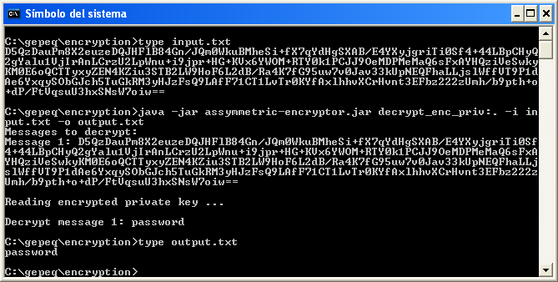

**WARNING:** Any user with the encryption tool and access to the *‘private.key’* file containing the encryption private key can decrypt the encrypted data from configuration files, so it is recommended to deny access to *‘private.key’* files within *‘WEB­INF/security’* folders to non trusted users.

## Encryption for arguments of web services of ‘OpenMark Test Navigator’ web applications

Some web services of *'OpenMark Test Navigator'* web applications perform dangerous operations if an attacker manages to make use of them.

It is therefore recommended that these web services can not be accessed externally to the machine running the OpenMark authoring tool.

Furthermore, as an additional security measure, you can configure web services of *‘OpenMark Test Navigator’* web applications, for both preview environment (*om­tn*) and publication environment (*om­tn­pro*), to receive certain arguments encrypted.

This is done using symmetric encryption for being faster than asymmetric encryption.

For symmetric encryption is not required a pair of encryption keys, but it is enough an encryption key that will serve both to encrypt and decrypt.

To generate the encryption key you must use another encryption tool which is also located at *‘encryption’* folder:

*java -jar symmetric-encryptor.jar generate-salted-password -o salted_password.txt*

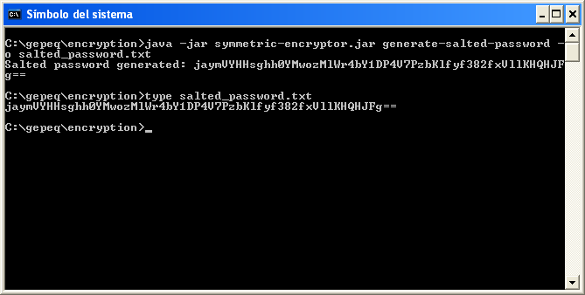

Running this command generates a random symmetric encryption key within *‘salted_password.txt’* file.

We can repeat the process and use 2 different encryption keys, one for the preview environment (*om­tn*) of 'OpenMark Test Navigator' web application implementation and the other for the publication environment (*om­tn­pro*), or we can use the same key for both.

In either case you must assign the generated encryption key to the *<gepeq­decryption­password>* property within *‘navigator.xml’* file of the corresponding *‘OpenMark Test Navigator’* web application.

Finally within *‘configuration.xml’* file located within *‘webapps/gepeq/WEB­INF’* folder of Apache Tomcat server, you must assign the same encryption key that you assigned to the preview environment (*om­tn*) of *‘OpenMark Test Navigator’* web application to *<OmTnEncryptionPassword>* property and the same one that you assigned to the publication environment (*om­tn­pro*) to *<OmTnProEncryptionPassword>* property.